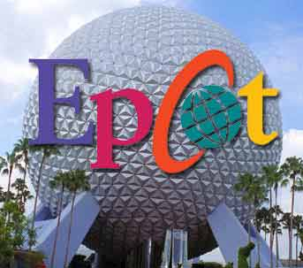
The park's name, EPCOT, is an acronym for Experimental Prototype Community of Tomorrow, a utopian city of the future planned by Walt Disney, often interchanging "city" and "community."

Students, we are going to work as a community to create a city which is governed by one of the three types of governments we are learning about during the school year!
Autocratic, Parliamentary Democracy or Presidential Democracy
Assignment: Choose a country from Europe, Latin America, or a Canadian Province. Then, imagine a city in that region of the world! Remember, you are creating a Paper Town. A Paper Town was the invention of cartographers to ensure their maps were not copied.
Make your vision come to life!

